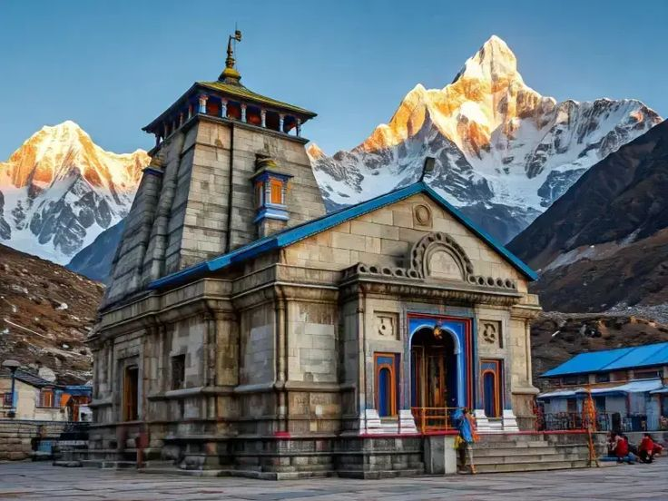
In the lap of aLLMIGHTY
Circuit: Guptkashi – Kedarnath – Ukhimath – Chopta – Tungnath
ITINERARY:
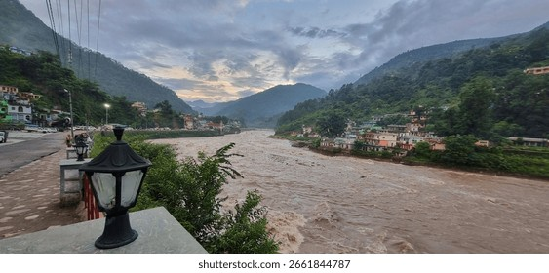
DAY 01: | 21 APR’26| RISHIKESH – GUPTKASHI (180 KMS , 05 – 06 HRS DRIVE)
After breakfast, drive towards Guptkashi through the scenic Mandakini Valley, enjoying beautiful views of flowing rivers, forested mountains, and charming Himalayan villages along the way. The route largely follows the sacred Mandakini River, offering picturesque landscapes and glimpses of local life in the Garhwal Himalayas. Upon arrival in Guptkashi, check in at the hotel and relax, taking in the serene surroundings of this peaceful Himalayan town.

Overnight stay in Guptkashi

DAY 02: | 22 APR’26| GUPTKASHI
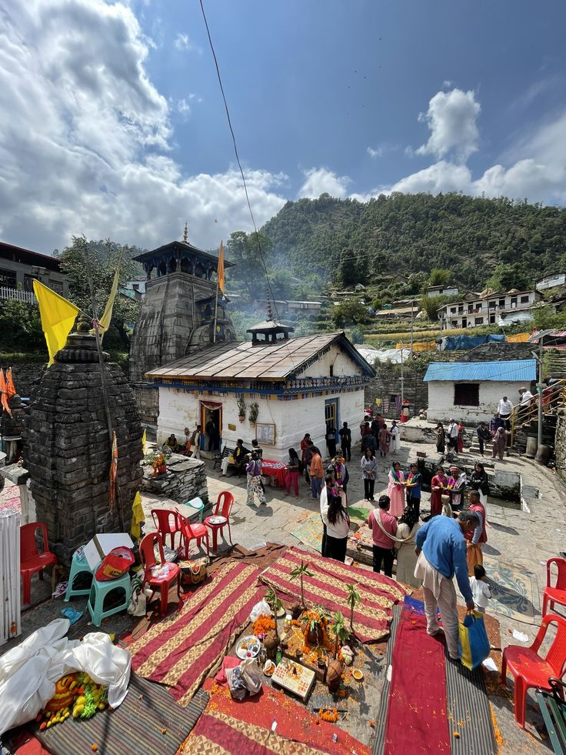
Today visit the important temples around the region, beginning with the sacred Triyuginarayan Temple, believed to be the divine site where Lord Shiva and Goddess Parvati were married. According to legend, the eternal flame burning in front of the temple marks the sacred fire that witnessed their celestial wedding. Surrounded by serene Himalayan landscapes and traditional mountain villages, the temple holds immense religious and cultural significance for devotees. Later, return to Guptkashi to visit the revered Vishwanath Temple, an ancient shrine dedicated to Lord Shiva. The temple is known for its spiritual atmosphere and architectural resemblance to the famous Vishwanath Temple in Varanasi, making it an important pilgrimage site in the region. Continue your excursion to the sacred Kalimath Temple, one of the significant Shakti Peeths in the Garhwal Himalayas, dedicated to Goddess Kali. Nestled amidst picturesque surroundings along the banks of the Kali River, the temple is deeply revered and offers a tranquil setting for prayer and reflection before returning to your hotel.

Overnight stay in Guptkashi

DAY 03: | 23 APR’26| GUPTKASHI – GAURIKUND (32 KMS, 01 HRS DRIVE) – KEDARNATH (TREK: 21 KMS ONE WAY, 07 – 08 HRS TREK)
After breakfast, drive to Gaurikund, the starting point of the sacred trek to Kedarnath Temple. Situated at the base of the Himalayas, Gaurikund is an important pilgrimage site associated with Goddess Parvati and serves as the gateway for devotees undertaking the journey to Kedarnath. From here, begin the trek towards Kedarnath through breathtaking Himalayan landscapes. The trail winds through rugged mountain paths, scenic valleys, cascading streams, and spectacular views of snow-capped peaks, offering a spiritually uplifting and visually rewarding experience throughout the journey. Upon arrival at Kedarnath Temple, one of the holiest shrines dedicated to Lord Shiva and an important part of the Char Dham pilgrimage circuit, check in at a lodge or guesthouse. Spend the rest of the day resting and relaxing after the long but fulfilling trek in preparation for visiting the sacred temple.

Overnight stay in Kedarnath

DAY 04: | 24 APR’26| KEDARNATH – GAURIKUND (TREK: 21 KMS ONE WAY, 07 – 08 HRS TREK) –
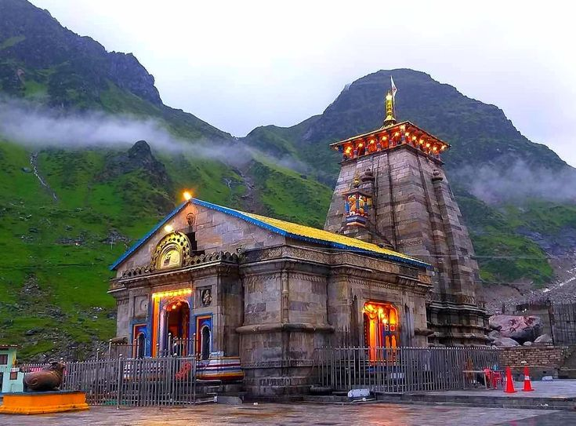
UKHIMATH (44 KMS, 01 – 02 HRS DRIVE)
Early in the morning, visit the sacred Kedarnath Temple for darshan. Nestled amidst the majestic Garhwal Himalayas and dedicated to Lord Shiva, the temple is one of the most revered shrines in India and forms an important part of the Char Dham pilgrimage. The serene spiritual atmosphere and the spectacular mountain surroundings make the experience truly memorable. After breakfast, begin the trek down to Gaurikund, the base point of the Kedarnath pilgrimage. Upon reaching Gaurikund, continue the scenic drive through the picturesque Himalayan landscape to Ukhimath.
Upon arrival in Ukhimath, check in at the hotel and spend the rest of the day at leisure, relaxing and enjoying the peaceful mountain surroundings after the rewarding pilgrimage journey.

Overnight stay Ukhimath

DAY 05: | 25 APR’26| UKHIMATH – CHOPTA (47 KMS, 01 HRS DRIVE)
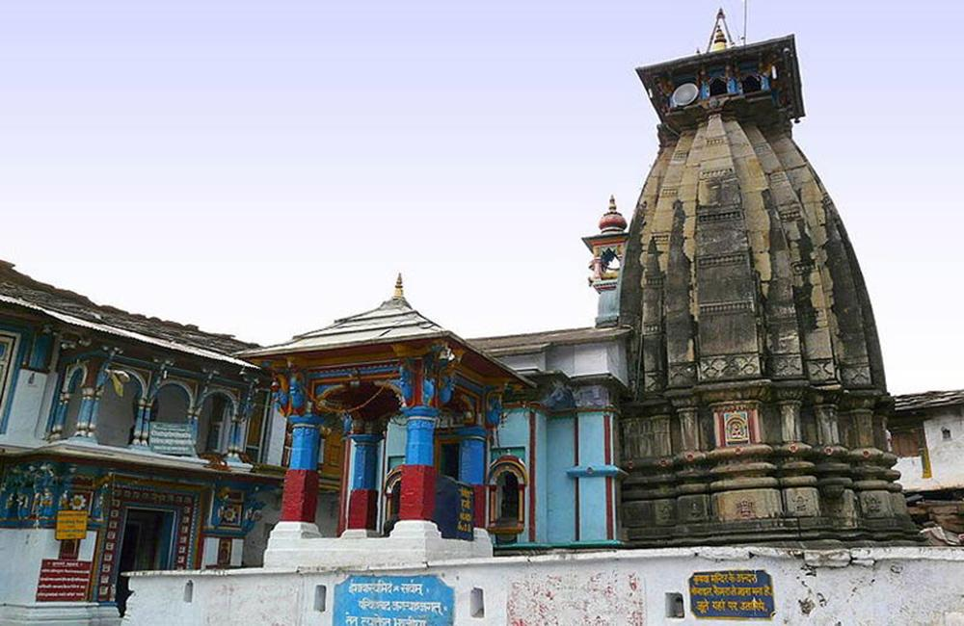
After breakfast, visit the sacred Omkareshwar Temple in Ukhimath, which serves as the winter seat of Lord Kedarnath. During the winter months, when heavy snowfall makes access to Kedarnath Temple difficult, the idol of Lord Kedarnath is ceremonially brought here and worshipped until the shrine reopens in spring. The temple holds great spiritual significance and offers a peaceful setting amidst the Himalayan surroundings. Later, drive towards Chopta near Baniyakund, a picturesque meadow region often

referred to as the “Mini Switzerland of Uttarakhand.” Surrounded by dense forests of rhododendron and deodar, and offering magnificent views of the Himalayan peaks, Chopta is known for its pristine natural beauty and tranquil environment. Upon arrival, check in at your accommodation and spend the rest of the day at leisure, relaxing and soaking in the serene mountain landscape.

Overnight stay in Chopta

DAY 06: | 26 APR’26| CHOPTA
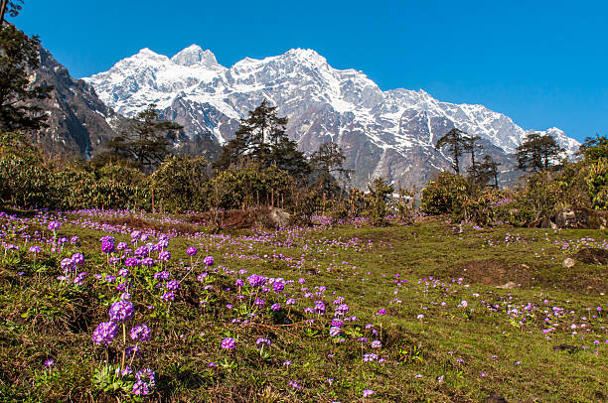
Today is a relaxed day in Chopta as you prepare for tomorrow’s trek to Tungnath Temple and Chandrashila Peak. Surrounded by dense forests and spectacular Himalayan scenery, Chopta offers a peaceful setting to unwind and acclimatize. You may take a short hike through the beautiful meadows around Chopta, which are well known for their rich birdlife and unique alpine vegetation. The trails pass through scenic grasslands and forested areas, providing wonderful opportunities to observe the natural beauty of the region. During the walk, your guide will share interesting insights about the local flora, fauna, and the fragile Himalayan ecosystem that thrives in this high-altitude environment. Return to your accommodation later in the day and spend the evening at leisure, enjoying the serene mountain atmosphere and preparing for the memorable trek ahead.

Overnight stay in Chopta

DAY 07: | 27 APR’26| CHOPTA – TUNGNATH (20 MNTS DRIVE & 06 – 07 HRS TREK BOTH WAYS) – CHOPTA
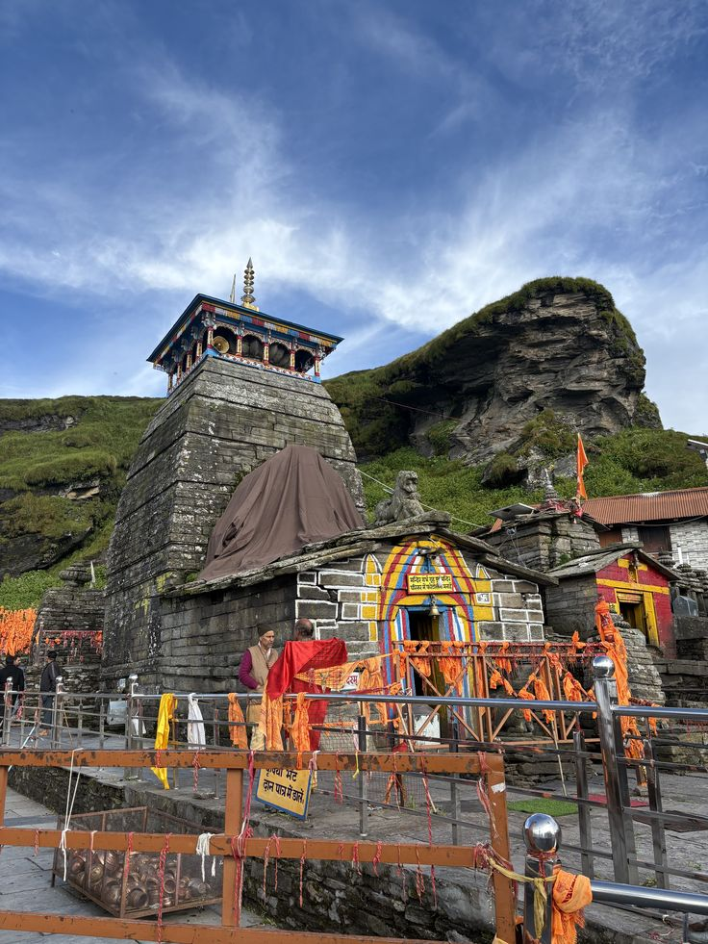
After an early breakfast, begin the scenic trek to Tungnath Temple, renowned as the highest temple in the world dedicated to Lord Shiva. The well-defined trail gradually ascends through picturesque alpine meadows and rhododendron forests, offering breathtaking views of the surrounding Himalayan landscape. Please note that the temple officially opens for worship on 10 May. However, visitors can still reach the temple premises and view the shrine from outside while enjoying the serene mountain surroundings and the spiritual ambiance of the site. Those interested may continue further to Chandrashila Peak, located about 1 km ahead of the temple. The final ascent is slightly more demanding but highly rewarding, as the summit offers spectacular panoramic views of the Himalayan peaks, including Nanda Devi, Trishul, Chaukhamba, and Kedarnath Peak. After spending some time at the summit and soaking in the magnificent views, begin the descent along the same trail back to Chopta.

Overnight stay in Chopta

DAY 08: | 28 APR’26| CHOPTA – RISHIKESH (159 KMS, 07 HRS DRIVE)
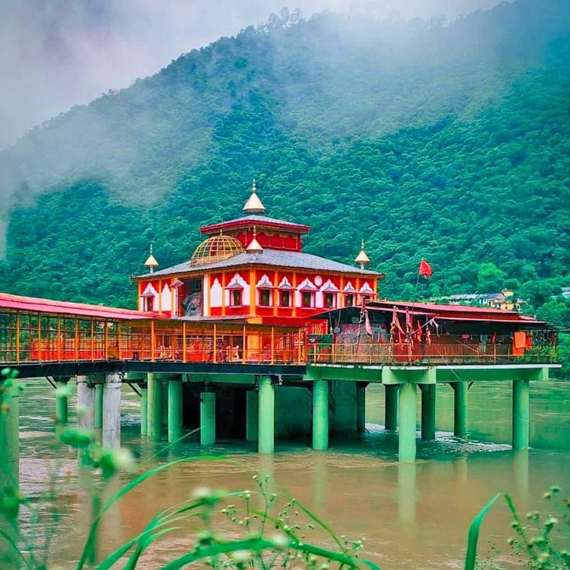
After breakfast, drive back to Rishikesh. En route, stop at the revered Dhari Devi Temple, one of the most sacred shrines in the region dedicated to Goddess Dhari Devi. The temple is uniquely situated on a rock in the middle of the Alaknanda River, creating a dramatic and spiritually powerful setting amidst the surrounding mountains. Goddess Dhari Devi is regarded as the guardian deity of the region, and it is widely believed that she protects the sacred Char Dham Yatra. The temple holds deep religious significance for pilgrims traveling to the Char Dham shrines and is visited by devotees seeking blessings for a safe and successful pilgrimage. After darshan at the temple, continue the scenic drive through the Garhwal Himalayas to Rishikesh. Upon arrival, spend the evening at leisure, relaxing or enjoying the peaceful spiritual ambiance along the banks of the sacred Ganges River.

Overnight stay in Rishikesh (OWN ACCOMODATION)

TOUR COST
CATEGORY | COST PER PERSON
Cost 02 paying pax | INR 1,69,542 per person
Supplement for Rishikesh accomodation at Antalya | INR 14,248 per room per night

City | Hotel | Date | Night
Guptkashi | Amritara or similar | 21 – 23 Apr’25 | 02
Kedarnath | Deluxe Guest House or similar | 23 – 24 Apr’26 | 01
Ukhimath | Regenta Madhuganga or similar | 24 – 25 Apr’26 | 01
Chopta | Chopta Resort or similar | 25 – 28 Apr’26 | 03
Total, number of nights |  |  | 07 Nights

Our prices include:

Price per person in a double room.

Half Board (Breakfast, Dinner) at all places.

Arrival / departure transfers, sightseeing tour excursion by Non A/C Toyota Crysta vehicle in hilly áreas during the tour.

Tour leader cum escort starting from arrival at Dehradun airport till departure from Dehradun airport.

All permit and entry fees for the Trek

Basic First Aid support

02 night in Guptkashi with half board basis (Breakfast, Dinner).

01 night in Kedarnath with half board basis (Breakfast, Dinner).

01 night in Ukhimath with bed and breakfast (Breakfast, Dinner).

03 night in Chopta with half board basis (Breakfast, Dinner).

Government tax (5%).

Our prices do not include:

Beverages.

Any services not mentioned as included, including personal extras such as telephone calls, laundry service, etc

Transportation in Delhi

Accomodation in Rishikesh

Delhi accomodation.

Entry visa. Visas can be obtained online at: www.indianvisaonline.gov.in

Tips for guides (at the client's discretion).

Travel and cancellation insurance (optional).

